# Target & Taylor Diagrams

Peter A. Rochford

Symplectic, LLC

4024 Goss Rd  
Fairfax, VA 22032-1306

Created: 9/29/2017

Revised: 12/20/2017

# Statistical Metrics

Several statistical metrics are used to provide a quantitative measure of agreement in the V&V conducted for HPAC and they are defined here for clarity and convenience of reference. These metrics measure the differences between a model field (m) and a reference field (r) that each represent a vector of data values having the same number of elements (i.e. length). These vectors can contain any set of values such as a spatial distribution of a physical quantity (e.g. concentration) or a time series of a physical quantity at a fixed location. The model field is output from the numerical model, and the reference field the corresponding quantity the model seeks to replicate, such as another model’s output, or observational data obtained from sources such as field tests. Metrics used for the V&V are bias (B), the correlation coefficient (R), the root-mean-square difference (RMSD), the unbiased RMSD (RMSD’), and the standard deviations of the model field (σm) and the reference field (σr). Their formulas are given by

$$B=\overline{m}- \overline{r}$$

$$R= \frac{\frac{1}{N}\sum_{n=1}^{N}{\left(m_{n}-\overline{m}\right)\left(r_{n}-\overline{r}\right)}}{σ_{m}σ_{r}}$$

$${RMSD}^{2}=\frac{1}{N}\sum_{n=1}^{N}{{\left(m_{n}-r_{n}\right)}^{2}}$$

$${{RMSD}^{'}}^{2}=\frac{1}{N}\sum_{n=1}^{N}{{\left[\left(m_{n}-\overline{m}\right)-\left(r_{n}-\overline{r}\right)\right]}^{2}}$$

$${σ_{m}}^{2}=\frac{1}{N}\sum_{n=1}^{N}{{\left(m_{n}-\overline{m}\right)}^{2}}$$

$${σ_{r}}^{2}=\frac{1}{N}\sum_{n=1}^{N}{{\left(r_{n}-\overline{r}\right)}^{2}}$$

where an overbar on the model or reference field is used to indicate the mean

$$\overline{m}=\frac{1}{N}\sum_{n=1}^{N}{m_{n}}$$

Note that there are relationships between these statistical metrics which are given by [ (Jolliff, et al., 2009), p. 67; (Taylor, 2001), p. 7184]

$${RMSD}^{2}=B^{2}+{{RMSD}^{'}}^{2}$$

$${{RMSD}^{'}}^{2}={σ_{m}}^{2}+{σ_{r}}^{2}-2σ_{m}σ_{r}R$$

These relationships are exploited in constructing mathematical diagrams for comparing the predictive skill of different models, namely target and Taylor diagrams (2).

# Model Predictive Skill Diagrams

Evaluation of the predictive skill of atmospheric and ocean models generally rely on analyzing the values provided by a variety of statistical metrics (Zhang, Hess, & Aikman, 2010). While this analysis may be relatively straightforward when using a few metrics, it can become complicated when considering multiple model predictions, either for different model parameterizations, with respect to multiple references, or many models. To aid in this analysis, mathematical diagrams have been designed to graphically indicate which models provide the best predictive skill relative to a chosen reference. Two particular types of diagram that are simple to interpret and are widely used are the target diagram (Jolliff, et al., 2009) and Taylor diagram (Taylor, 2001). These diagrams provide a means to compile statistical measures of the predictive skill of multiple models into a single graph that facilitates comparison and analysis.

## Target Diagram

The target diagram is derived from the relation between the statistical metrics of bias (B), unbiased root-mean-square difference (RMSD’), and RMSD (cf. 1) and makes use of a Cartesian coordinate system where the x-axis represents the RMSD’ (variance of the error) and the y-axis represents B. Since these three metrics are related by the equation (cf. 1)

${RMSD}^{2}=B^{2}+{{RMSD}^{'}}^{2}$,

the distance between any point to the origin is equal to the RMSD, contours of which leads to the diagram having the appearance of a common target poster (hence the name’s origin).

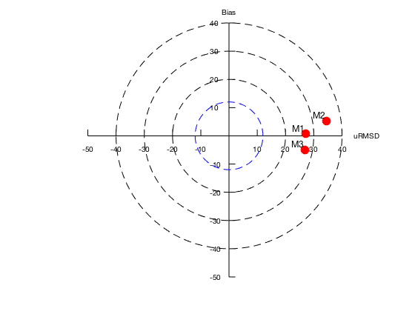

Figure 1. Example target diagram.

The sample target diagram shown in Figure 1 provides a summary of the relative skill of three model predictions, each represented by a different letter on the diagram (M1, M2, & M3), with respect to a set of reference observations. The reference data are cell concentrations of a phytoplankton in µM/L collected from cruise surveys at selected locations and time. The model predictions are from three different simulations that have been space-time interpolated to the location and time of the sample collection. “The … diagram provides three different measures: whether the model overestimates or underestimates (positive or negative values of the [bias] on the y-axis, respectively), whether the model standard deviation is larger or smaller than the standard deviation of the measurements (positive or negative values on the x-axis, respectively), and the error performance as quantified by the [RMSD] represented as the distance to the coordinates origin.” (Lamigueiro, 2017) The dashed blue line about the origin that forms a “bull’s eye” indicates the observational uncertainty and communicates the estimated limits of model performance. Note that the area to the left of the origin is always empty of data points because the unbiased RMSD is always positive. However, this region is sometimes used with the benefit of additional information, such as by multiplying the unbiased RMSD by the sign of the difference between the standard deviations of model and reference fields. The diagram reveals that model predictions M1 and M3 have a smaller RMSD’ (uRMSD) than M2, with M1 having a smaller bias than M3. It is evident that M1 provides the best model prediction because it is closest to both the origin and has the smallest bias.

This diagram provides insight into predictive skill when comparing competing models by providing “summary information about how the magnitude and sign of the bias and the pattern agreement (unbiased RMSD) each contribute to the total RMSD magnitude.” (Jolliff, et al., 2009). Note that “[m]arkers may be added to the diagram in order to: (1) help identify limits based upon the correlation coefficient; (2) provide an assessment of model performance compared to an observational average (marker M0); and (3) indicate potential limits to model performance improvement when the average observational uncertainty has been estimated.” (Jolliff, et al., 2009).

## Taylor Diagram

Taylor diagrams display three statistics that are useful for assessing the degree of correspondence between the modeled and observed behavior: the Pearson correlation coefficient (R), the standard deviations of the model (σm) and reference (σr) fields, and the unbiased RMSD (RMSD’) (cf. 1). Mathematically, the three statistics are related by the following formula

${{RMSD}^{'}}^{2}={σ_{m}}^{2}+{σ_{r}}^{2}-2σ_{m}σ_{r}R$,

and it’s the similarity of this relation to the Law of Cosines

$$c^{2}=a^{2}+b^{2}-2ab\cos{φ}$$

that provides the key to forming the geometrical relationship between the four quantities that underlie the Taylor diagram. “Note that the means of the fields are subtracted out before computing their second-order statistics, so the diagram does not provide information about overall biases, but solely characterizes the centered pattern error.” (Wikipedia, 2017)

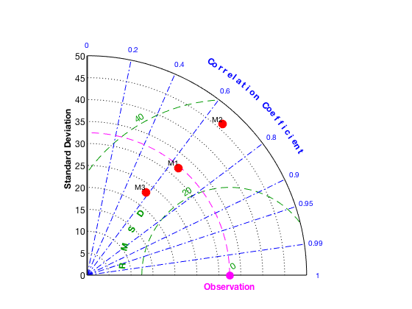

Figure 2. Example Taylor diagram.

The sample Taylor diagram shown in Figure 2 for the same data as used above for the target diagram, provides a summary about how the linear correlation coefficient and the variance of the three model predictions, separately indicated by a different letter (M1, M2, & M3), each contribute to the unbiased RMSD on a two-dimensional diagram. The distance between each model and the point labeled “Observation” is a measure of how each model reproduces observations. “For each model, three statistics are plotted: the Pearson correlation coefficient (gauging similarity in pattern between the simulated and observed fields) is related to the azimuthal angle (blue contours); the … [RMSD] … in the simulated field is proportional to the distance from the point on the x-axis identified as “observed” (green contours); and the standard deviation of the simulated pattern is proportional to the radial distance from the origin (black contours). … The relative merits of various models can be inferred from [the diagram]. The dashed magenta line about the origin indicates the standard deviation in the observations. Simulated patterns that agree well with observations will lie nearest the point marked [“Observation”] on the x-axis. … Models lying on the dashed arc have the correct standard deviation (which indicates that the pattern variations are of the right amplitude).” (Wikipedia, 2017) This sample diagram reveals that the model predictions M1 and M3 have a smaller standard deviation and RMSD than M2, but that the latter has a slightly higher correlation. As found in the target diagram (Figure 1), it is evident that M1 provides the best model prediction because it is closest in distance to the center of the RMSD circles, where the latter indicates the standard deviation of the reference observations.

## Summary

Target diagrams are Cartesian plots that summarize how well patterns match each other in terms magnitude (bias) and how they each contribute to the total RMSD; whereas Taylor diagrams are polar coordinate plots that provide a concise statistical summary of how well patterns match each other in terms of their correlation, their RMSD, and the ratio of their variances. It is important to observe that “Both methods presume that RMSD-based metrics are sufficient criteria upon which to base model skill assessment, and this may not always be the case.” (Jolliff, et al., 2009) Finally, note that open source software packages are available to easily construct target and Taylor diagrams using MATLAB (Rochford, Skill Metrics Toolbox, 2017; Rochford, SkillMetricsToolbox, 2017), Python (Rochford, SkillMetrics, 2017), R (Lamigueiro, 2017; MRAN, 2017), as well as other languages.

# References

Jolliff, J. K., Kindle, J. C., Shulman, I., Penta, B., Friedrichs, M., Helber, R., & Arnone, R. (2009). Skill Assessment for Coupled Biological/Physical Models of Marine Systems. *Journal of Marine Systems*, 64-82. doi:doi:10.1016/j.jmarsys.2008.05.014

Lamigueiro, O. P. (2017, October 5). *Target Diagrams*. Retrieved from GitHub: https://github.com/oscarperpinan/tdr

MRAN. (2017, October 5). *plotrix : Various Plotting Functions*. Retrieved from MRAN: https://mran.microsoft.com/package/plotrix/

Rochford, P. A. (2017, October 5). *Skill Metrics Toolbox*. Retrieved from MathWorks File Exchange: https://www.mathworks.com/matlabcentral/fileexchange/52943-peterrochford-skillmetricstoolbox

Rochford, P. A. (2017, October 5). *SkillMetrics*. Retrieved from GitHub: https://github.com/PeterRochford/SkillMetrics/

Rochford, P. A. (2017, October 5). *SkillMetricsToolbox*. Retrieved from GitHub: https://github.com/PeterRochford/SkillMetricsToolbox

Taylor, K. E. (2001). Summarizing Multiple Aspects of Model Performance in a Single Diagram. *Journal of Geophysical Research, 106*(D7), 7183–7192. doi:doi:10.1029/2000JD900719

Wikipedia. (2017, 10 12). *Taylor diagram*. Retrieved from Wikipedia: https://en.wikipedia.org/wiki/Taylor_diagram

Zhang, A., Hess, K. W., & Aikman, F. (2010). User-based Skill Assessment Techniques for Operational Hydrodynamic Forecast Systems. *Journal of Operational Oceanography, 3*(2), 11-24. doi:http://dx.doi.org/10.1080/1755876X.2010.11020114